DSA 0601 - Data handling and visualization
Set 1 - Monthly Sales Data

Name : B.Jahnavi
Reg.no:192325043

1.Line graph
Code:
library(ggplot2)

sales <- data.frame(
Month = c("January", "February", "March", "April", "May","June", "July", "August", "September", "October","November", "December"),
Sales = c(15000, 18000, 22000, 20000, 23000, 25000,27000, 26000, 29000, 31000, 33000, 35000))

ggplot(sales, aes(x = Month, y = Sales, group = 1)) +
geom_line() +geom_point() +labs(title = "Monthly Sales", x = "Month", y = "Sales") +
theme_minimal()

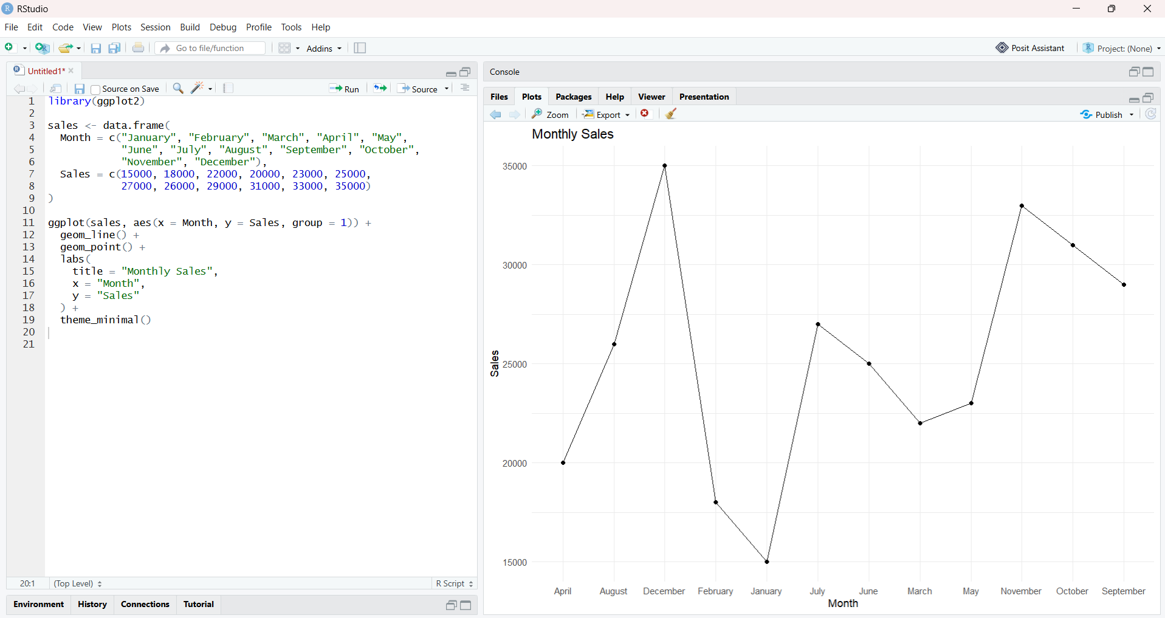

- Bar graph
Code:
products <- data.frame(
Product = c("Product A", "Product B", "Product C","Product D", "Product E"),
Sales = c(95000, 82000, 76000, 68000, 55000)

ggplot(products, aes(x = Product, y = Sales)) +
geom_bar(stat = "identity") +
geom_text(aes(label = Sales), vjust = -0.5) +
labs(
title = "Top-Selling Products",
x = "Product",
y = "Sales ) +theme_minimal()
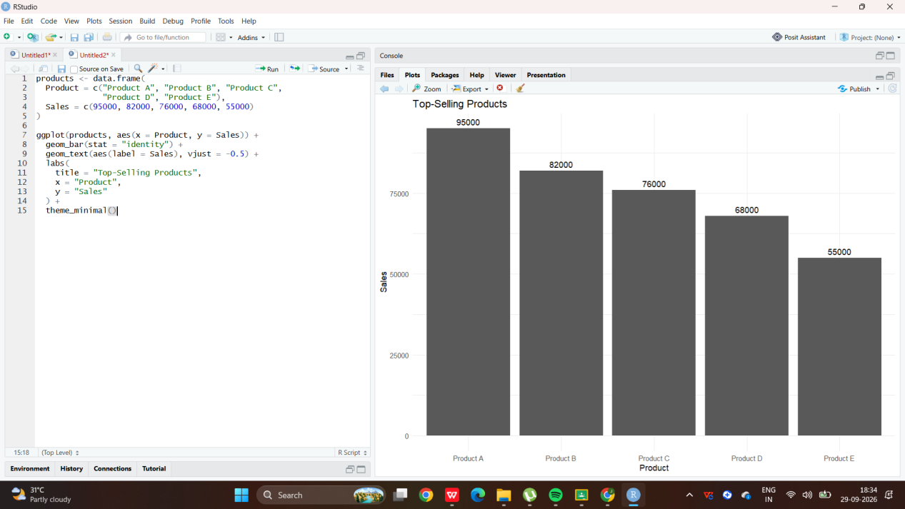

- Scatterplot
Code:
advertising <- data.frame(
Advertising_Budget = c(5000, 6000, 7000, 6500, 8000, 8500,9000, 8800, 9500, 10000, 11000, 12000),
Sales = c(15000, 18000, 22000, 20000, 23000, 25000,27000, 26000, 29000, 31000, 33000, 35000))

ggplot(advertising,aes(x = Advertising_Budget, y = Sales) +
geom_point(size = 3) +
geom_smooth(method = "lm", se = FALSE) +
labs(title = "Advertising Budget vs Monthly Sales",x = "Advertising Budget",y = "Monthly Sales") +theme_minimal()

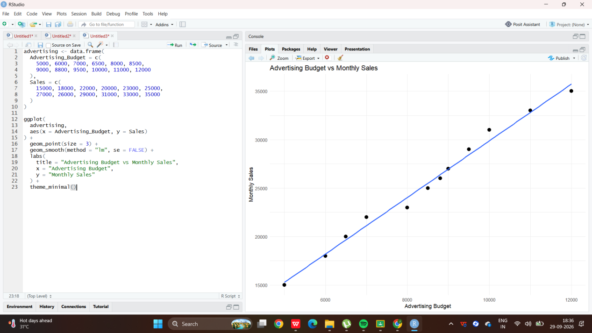
- Correlation
Code:
cor(
advertising$Advertising_Budget,
advertising$Sales
)

